ICAN BioCell - Flow Cytometry
APPLICATION FORM

I need:
☐ Cell sorting
☐ Cell analysis
☐ Soluble compounds analysis

I would prefer:
☐ To let the facility to do if for me
☐ To do it myself

Other services I need:
☐ Antibody panel design
☐ Cell staining
☐ Cell counting
☐ Data analysis

- Applicant details
User name and first name
Principal investigator name and first name
Laboratory, institution
Principal investigator phone and email
ICAN member (Y/N)
Co-PI detail

- Project details
Project title
Summary of project from which samples originated
Proposed project - Purpose

Details of specific assays requested
Preferred start date for project
Duration of project
Are there restrictions over publication and IP ownership? (please provide details)
Type of subjects or animals involved
Is the study covered by ethical approval?
All the analyzed subject have consented to the study?
CPP or APFIS number

- Original study details
Funder of original project
Was the original project peer-reviewed

- Sample details
For soluble compounds analysis
Sample type (plasma, serum, cell culture medium, …)
For cell sorting and/or analysis Cellular type (neural cell, adipocyte, IPS , organoides....)
Number of samples per slot/week
Fresh or frozen sample
Are the samples known to be hazardous (e.g. infectious and parasitic organisms; presence of radioactive substances)?
Would you like to give left over samples to ICAN CYTO ? (YES/NO)
Samples will be used for personnel training and quality controls
Would you like to inform ICAN CYTO of your quality control results? (YES/NO)
Results will be used to improve our services

Please, read these tips before coming at ICAN CYTO facility…

You have decided to join our flow cytometry facility to perform a cell sorting or an acquisition on one of our cytometers. Below is a reminder of the important conditions to be fulfilled for a flow cytometry experiment on the ICAN CYTO platform.

1. Make sure to use an antibody panel suitable for the optical benches of the various flow cytometry devices of the ICAN CYTO platform. Below is the description of the optical bench of each device. Please, feel free to use the Flow Cytometry Panel Builder available at https://app.fluorofinder.com/icancyto to set up your panel.
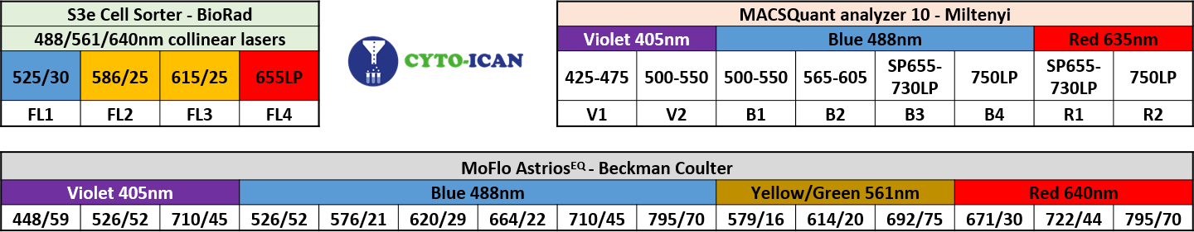

- Ensure the correct number of cells and the cell concentration of each sample
- Count your cells before labeling the cells
- Count your cells before going through the sorter and adjust the concentration
- Do not exceed 10.10⁶ cells / ml
- Ensure the specificity of the antibodies before the experiment of interest
- Always saturate non-specific binding sites (FcR blocking, inactivated serum, BSA)
- Check the specificity of the antibodies by labeling the cells with the isotype corresponding to the antibody used. It is strongly recommended to check the concentrations of antibody tubes and isotype tubes as well as the F / P (fluorescence / protein) ratio with the suppliers to label the cells under the same conditions.
- Ensure the correct concentrations of antibodies / isotypes to be used according to the different flow cytometry devices of the ICAN CYTO platform
- Always titrate the antibodies before the experiment of interest under the same experimental conditions and on the devices provided for the experiment of interest.
- Make sure you are observing living cells
- Always use a viability marker to eliminate dead cells that could bind antibodies in a non-specific way and be considered cells of interest.
- Make sure you have a cell suspension free of aggregates
- Filter your samples (50µm) just before acquisition on the cytometer for sorting.
- Maker sure you have a suitable collection medium for sorting cells or particles. Make sure to obtain enough cells for post-sorting applications
- It is recommended to perform a first sorting test to determine the number of cells, the sorting speed and the post-sorting viability, before the experiment of interest
- It is recommended to get information from the chosen sequencing platform about the number of sorted cells needed and the collection medium adapted according to the applications
- Make sure you have prepared and bring all the tubes necessary for the performance of the experiment of interest: control tubes for the adjustments, the fluorochromes compensations and the determination of the regions to be analyzed, and the samples of interest:
- Unstained = mixture of cells from each sample, unlabeled. It is strongly recommended to provide two unmarked sample tubes: one for PMT settings and one for the acquisition of compensation tubes (minimum 500,000 cells)
- Fully stained = mixture of cells from each sample, labeled with all the fluorochromes of the panel including the viability marker (minimum 500,000 cells)
- Single stained tubes = compensation beads or mixture of cells from each sample, labeled with each fluorochrome in the panel: one fluorochrome = one tube, including viability. It is strongly recommended to divide the viability tube into 2 and kill the cells from tube 1 (for example with 70% ethanol 1min), before washing the cells and resuspending them with tube 2, to finally add the viability marker (minimum 500,000 cells)
- FMO tubes = mixture of cells from each sample, labeled with all fluorochromes EXCEPT 1: one fluorochrome = one tube (minimum 500,000 cells)
- Samples = samples to be analyzed. For cell analysis, make sure you have enough cells to analyze a minimum of 20,000 cells.

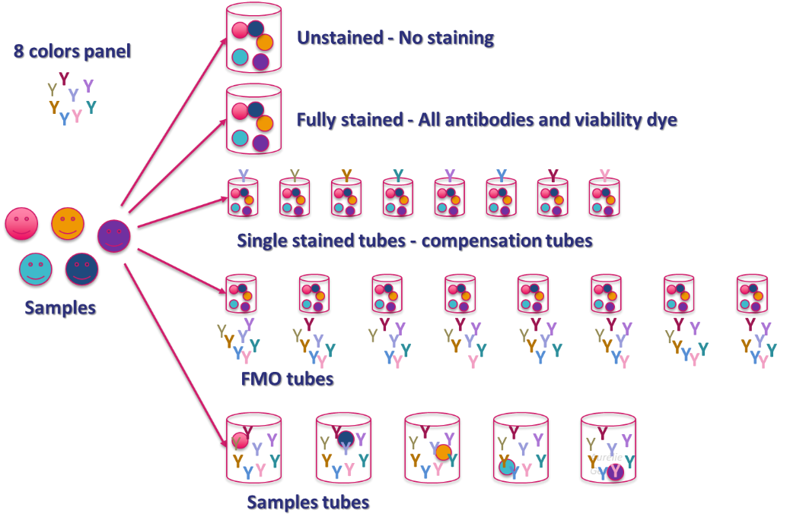
For example:

- Make sure you have all tubes and filters necessary to sort your cells
- 12*75mm 5ml round tubes - one per sample. Note that you can buy tubes on the ICAN Cyto platform at the cost of 2 euros each.
- 50µm filter - one per sample. Note that you can buy filters on the ICAN Cyto platform at the cost of 5 euros each.
- Collection tube : usually 1.5ml tubes. Note that you will need to inform the ICAN Cyto platform if you desire to sort your cells in 2ml tubes or 12*75mm 5ml round tubes or 96 well microplate for MoFlo Astrios^{EQ} or stripwell for S3e Cell Sorter
- Your preferred media to dilute your sample
- Your preferred media to collect your sorted sample

User signature Principal Investigator signature

